Kickstarter Campaign Analysis

Submitted by Stacy J. Giauque (T/Th/S Class)

Pivot Table, Stacked Column and Line Graph charts, based on a data set size of over 4,000 Kickstarter Campaigns:

Summary of Kickstarter Campaigns By Parent Category and success/failure/cancellation rates:

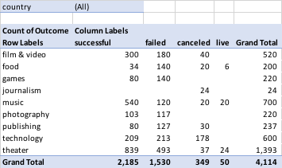

Visual representation of Kickstarter Campaigns by Parent Category and success/failure/cancellation rates:



Summary of Kickstarter Campaigns By Sub-Category and success/failure/cancellation rates:

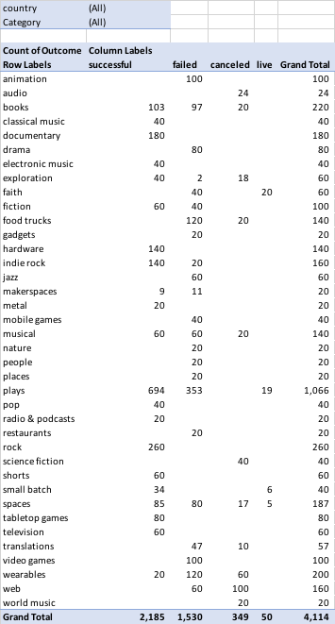

Visual representation of Kickstarter Campaigns by Parent Category and success/failure/cancellation rates:



Summary of Kickstarter Campaigns By Conversion Month and success/failure/cancellation rates:

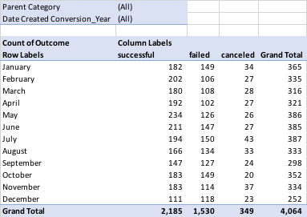

Visual representation of Kickstarter Campaigns by success/failure/cancellation rates by month:



Given the provided data, what are three conclusions we can draw about Kickstarter campaigns?

1. Overall, while Theatre as a category most successfully converts or secures funding for the largest number of campaigns at 839 campaigns, the category with the highest percentage of converted campaigns out of total campaigns launched, is actually Music, with a campaign success rate of 77.1%. This is in comparison to Theatre’s campaign success rate of 60.2%. (See Pivot_Category Tab.)
2. A deeper dive into the 3 Theatre sub-categories (ie. musicals, plays, and spaces) which drive the overall highest number of campaign successes (839), it becomes clear that Plays, or the Stage community, are the most active Kickstarter campaign contributors. The total number of successful Kickstarter campaigns in support of Plays is 694. The next highest group of successful campaign contributors are Music lovers who support Rock with 260 campaigns. (See Pivot_Sub Category Tab.)
3. While seemingly only somewhat correlated, based on the visual graph of campaign successes and failures by month, it appears that timing, month in which campaigns are launched, or calendarization does impact the success vs. failure of a campaign. It appears that campaigns launched in the first half of the year, and specifically in April and May have higher likelihood of success than in other months of the year. This is possibly due to timing relating to fund-raising in advance of quieter or less active summer months, especially in grass-roots, entrepreneurial, or not-for-profit arts, sectors. This is in contracts to December which reflects the lowest campaign success conversion rate. This is possibly, even likely, due to fundraising competition relative to year-end and holiday gift-giving alternatives.

What are some limitations of this dataset?

Some limitations of the dataset include:

* Lack of year-over-year, historical, or trending data for same or similar projects
* Segmentation or categorization of Backers, that is demographic or more specific geographic indicators, organization size vs. individual pledgers.
* Segmentation or categorization of Projects, that is demographic or more specific geographic indicators, organization size vs. individual project creators.
* While relatively easy to convert to like-for-like $USD amounts using spot FX rates, current funding amounts in the data set are not all in the same currency. Current data does not compare absolute dollars successfully funded or not funded.

What are some other possible tables and/or graphs that we could create?

Additional tables and/or graphs which could shed insight into the behavior of Kickstarter Project Categories and corresponding Backers include success/failure/cancel segmentation by country and/or currency.